NEWSPAPER

**User Guide**

**GROUP MEMBERS:**

|  |  |
| --- | --- |
| **Student1601467** | **VENESHA PERVAIZ** |
| **Student1605792** | **SAJAL ANWAR** |
| **Student1601465** | **AREEBA FAROOQ** |

**CURRICULUM: ACCP 7144 SEMESTER: CPISM**

**FACULTY:** **SIR HAFIZ FARZAN AHMED**

**CERTIFICATE OF RECOGNITION:**

This certificate is presented in recognition of the vital role newspapers, both in print and digital form, play in journalism. Their commitment to delivering timely news, detailed analysis, and comprehensive coverage of current events has made them a cornerstone of society. With their coverage of national and international issues, politics, business, entertainment, and sports, newspapers continue to inform citizens, shape public discourse, and influence opinion. As digital media has evolved, many newspapers have successfully adapted, expanding their reach through websites, mobile apps, and social media platforms. This recognition acknowledges their ongoing contributions to keeping the public informed and engaged in a rapidly changing world.

**Presented On: January 31, 2025**

**Authorized Personality:** **SIR HAFIZ FARZAN AHMED**

**ACKNOWLEDGEMENT:**

We would like to extend our heartfelt appreciation to all those who played a key role in ensuring the successful completion of this project.

Our sincere thanks go to **Sir Hafiz Farzan Ahmed** for offering invaluable advice and support throughout the entire process.

We are profoundly grateful to our colleagues and team members for their dedication, commitment, and teamwork. Their efforts have been instrumental in bringing this project to completion.

We are also incredibly grateful to our families for their unwavering love and encouragement, which has helped us remain focused and driven throughout this journey.

Lastly, we extend our heartfelt appreciation to all those who have offered their resources, guidance, and opportunities, which were vital in bringing this project to completion.

This project could not have been completed without the invaluable help and support from all of you. We truly appreciate your contributions. **Thank** **you**!

**SYNOPSIS:**

Newspaper websites have become vital platforms for accessing breaking news and comprehensive coverage of current affairs. These digital outlets cover a wide variety of subjects, including politics, business, entertainment, sports, and local news, all available in real-time. As the shift toward online media continues, many newspapers now feature interactive elements, multimedia content, and up-to-the-minute articles, making it easier for readers to stay updated. Additionally, these websites are increasingly prioritizing user interaction, providing spaces for feedback, comments, and discussions, which further enhances the connection between the publication and its audience.

**Categories:**

Newspaper websites have evolved into essential platforms for accessing real-time news and in-depth analysis, offering a wide array of topics such as politics, business, entertainment, and local events. These digital platforms have become crucial in informing the public across the globe, each adapting to the unique needs of their audiences. Here’s a look at how newspaper websites cater to readers in Pakistan, India, and China:

* **Pakistan:** Leading digital newspapers in Pakistan provide comprehensive coverage of local, national, and international news, alongside in-depth reporting on socio-political issues. These websites are increasingly interactive, offering readers the ability to engage in discussions and share opinions on the latest stories.
* **India:** India’s newspaper websites have become vibrant digital hubs, offering timely updates on politics, entertainment, sports, and more. With a diverse range of content in multiple languages, these websites cater to the varied interests of India’s vast population, while also incorporating multimedia content to enhance the reader experience.
* **China:** Chinese newspaper websites play a key role in keeping the public informed on both domestic and global affairs. With a focus on government news, business developments, and international relations, these websites have become critical sources of information for millions of readers across China.

**PROBLEM STATEMENT:**

DNBC is an established name News and Reporting. They have their network of reporters across the world.

They collect and send all news articles to the main office in London.

Main Office then prepares the news and publish it in newspaper in respective

segments.

To make news available in faster to the readers and subscribers, now company is planning to launch a website. This will help in bringing information and news faster and also readers can search and read news from any location.

The website which they demand is suppose to provide user friendly environment and navigation. The important menu must be stated in the top section of the webpage. Also a decent look out and color combination is expected.

The website is to be developed for the Windows Platform using HTML5, JavaScript and Geolocation. The site should work well in all leading browsers including Chrome, IE, Firefox etc.

**Requirement Specification:**

The Web site is to be created based on the following requirements.

1) The Home Page with headlines and other major activities happened should be provided. (Also navigational link must be included.)

2) The website must provide information like “About us”, “Today in World”,

“Sports”, “Business”, “Contact us” etc.

3) Each section must provide proper listing of news along with brief information.

4) Also each link must be properly hyperlinked, images must be used wherever necessary.

5) Facts and figures related to News should be provided.

6) Contact Us page must flash the address and location on map of the offices of DNBC.

7) Individual pages for various sections of news should be provided with detailed information and images.

8) Top Cities of the World (At least 5) should have separate page with some information about various activities happening in those cities.

9) All locations should be displayed using Maps (Geolocation).

10) Feedback must be taken on the information available on website.

**Guide:**

**NAVBAR :**

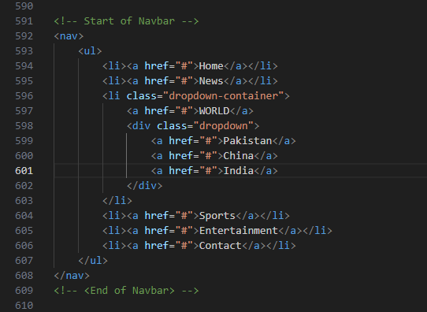

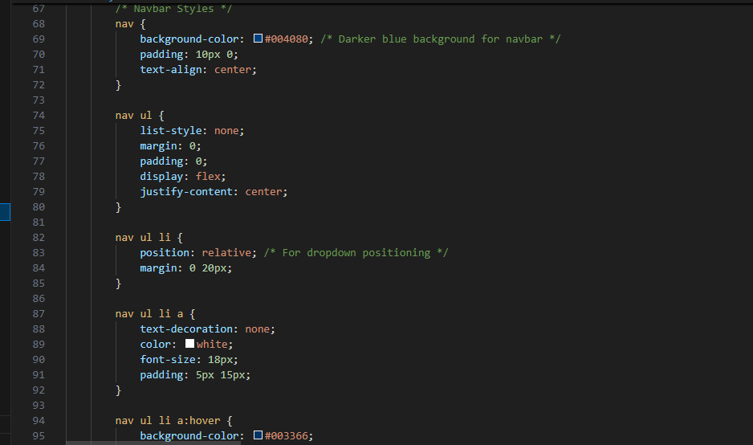

**CAROUSEL (HOME.HTML):**

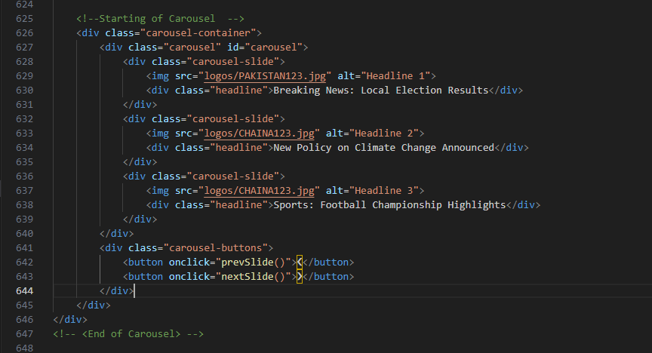

**CARDS (HOME.HTML):**

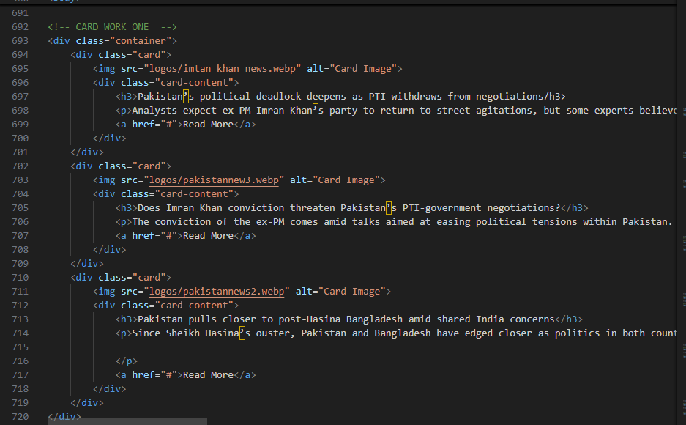



**QUERY FORM (HOME.HTML):**

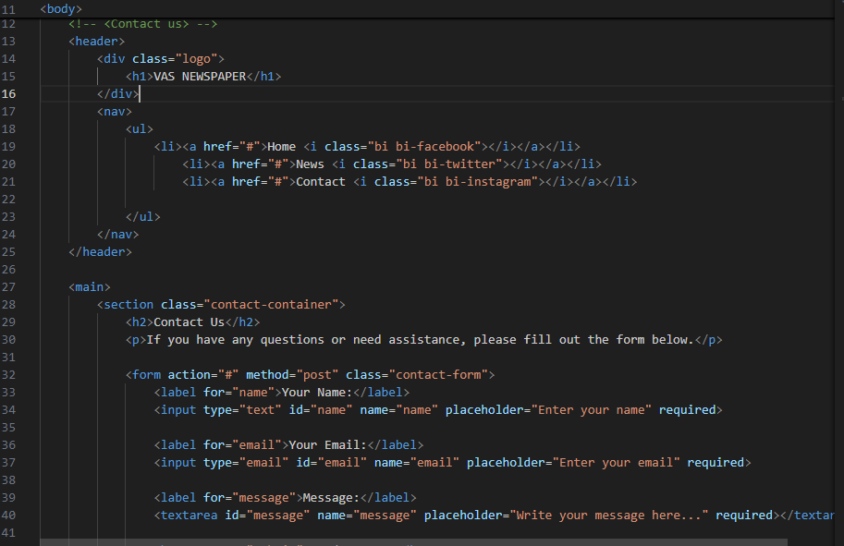

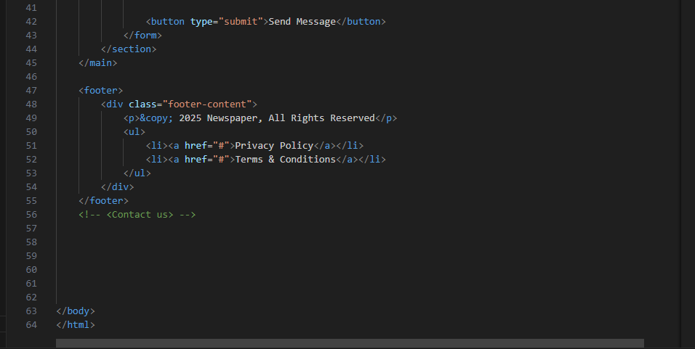

**QUERY FORM (CSS)**

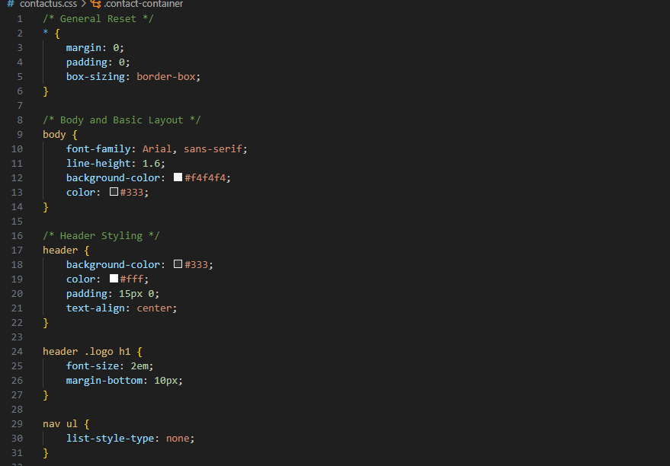

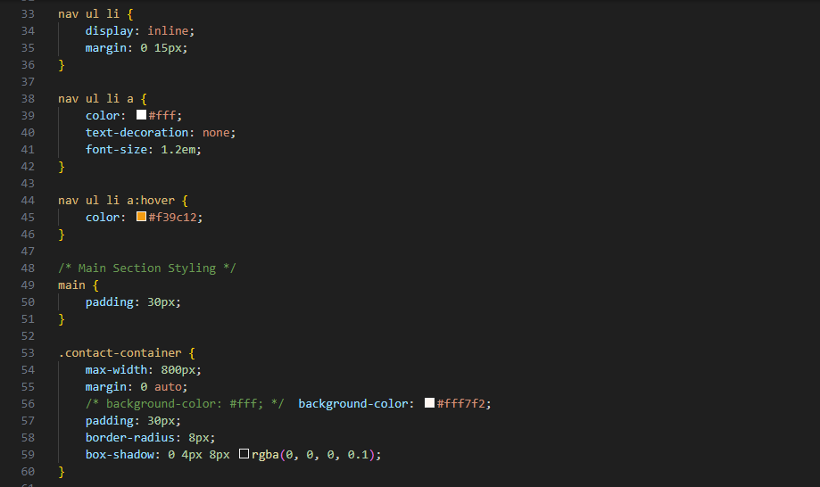

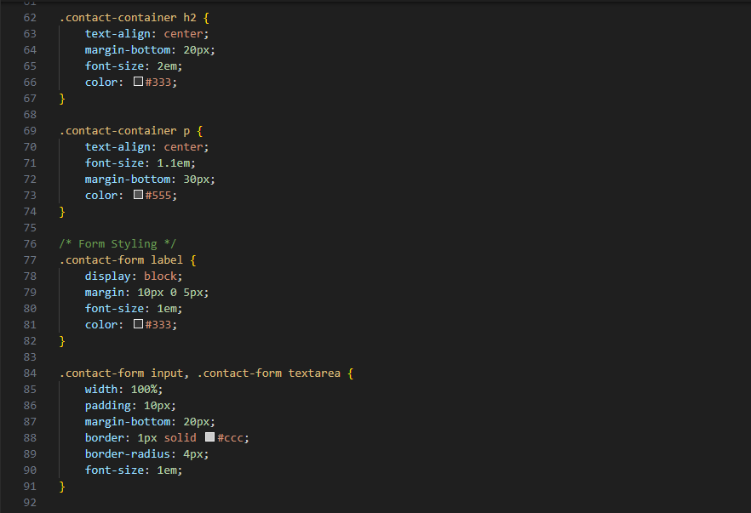

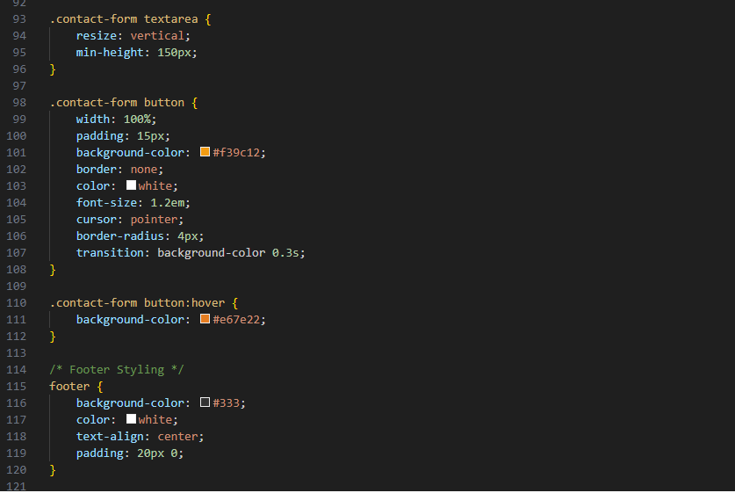

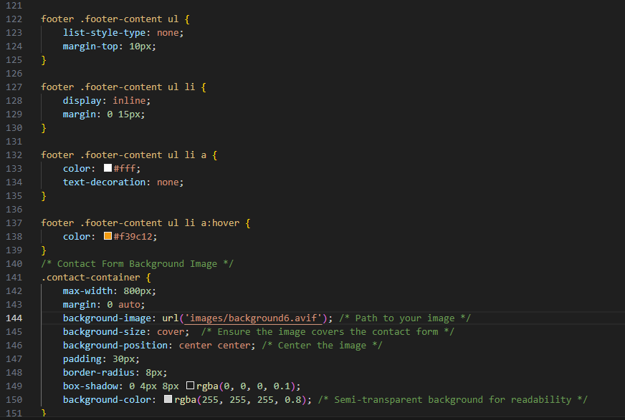

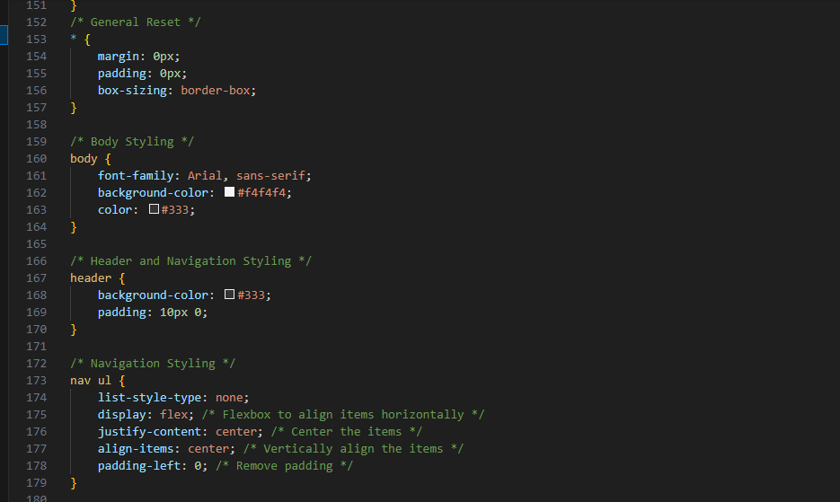

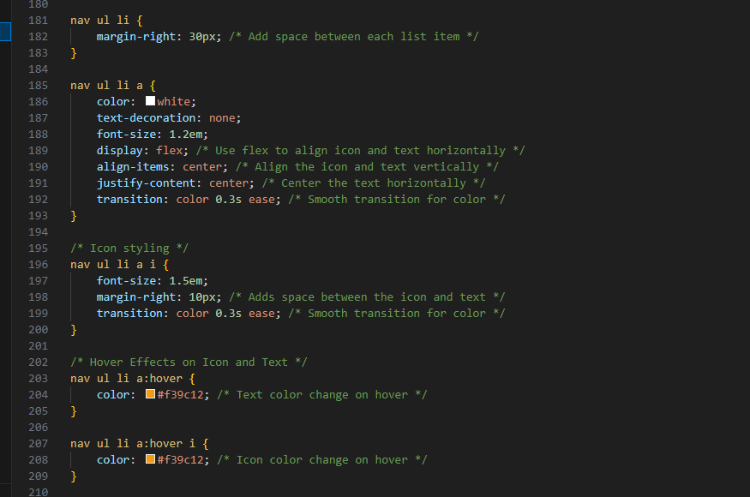

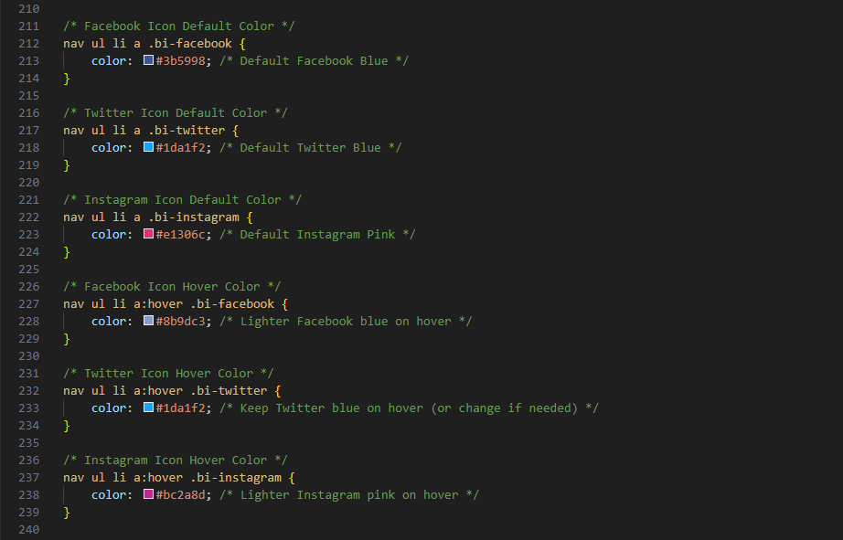

**FEEDBACK (HOME.HTML)**

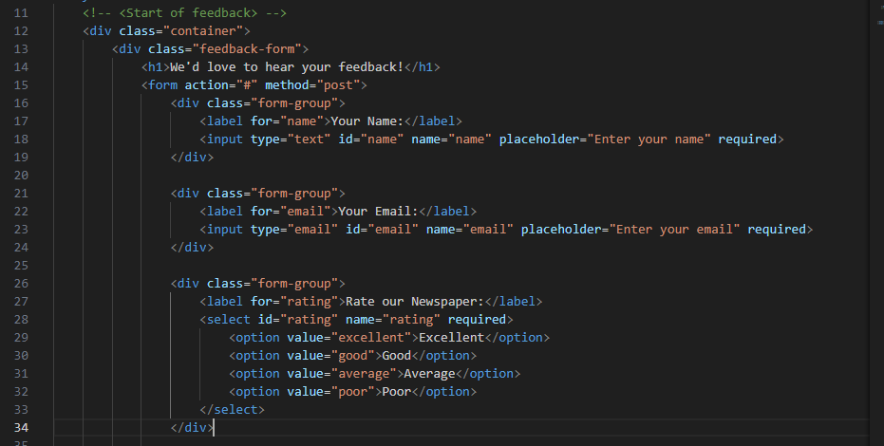

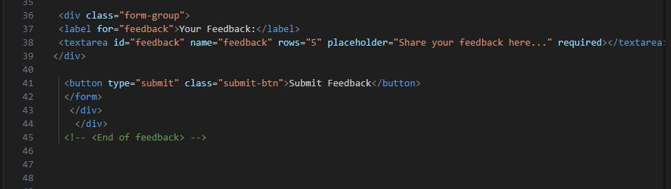

**FEEDBACK (CSS)**

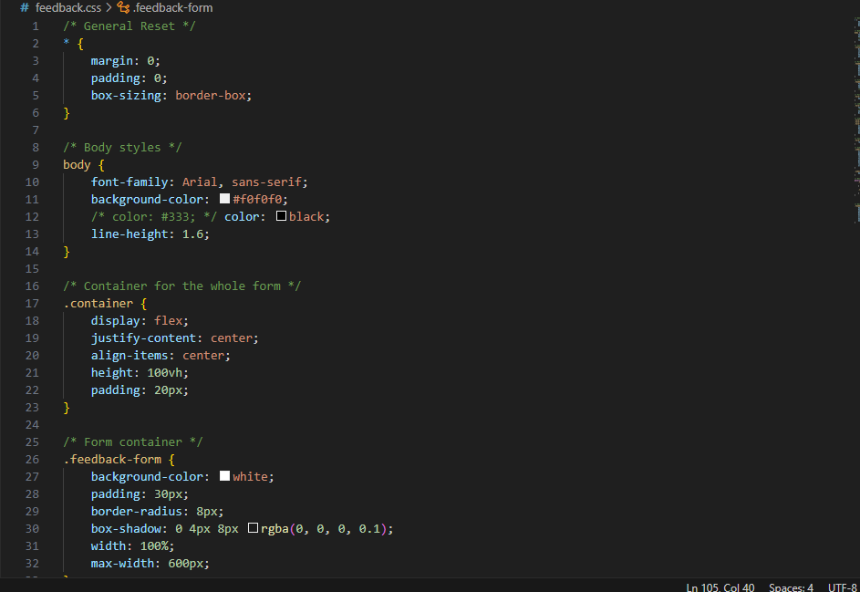

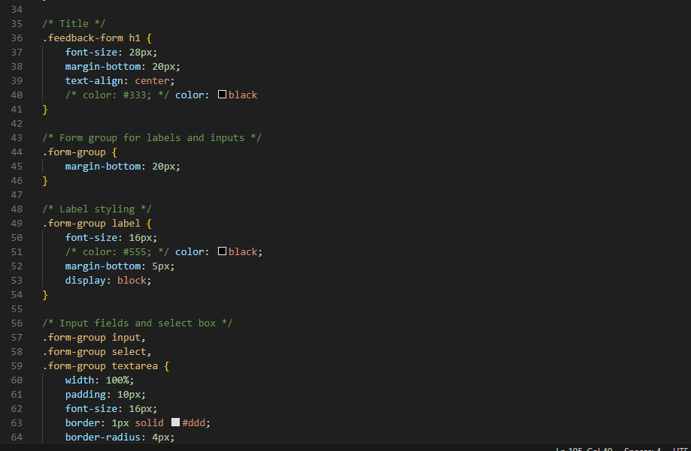

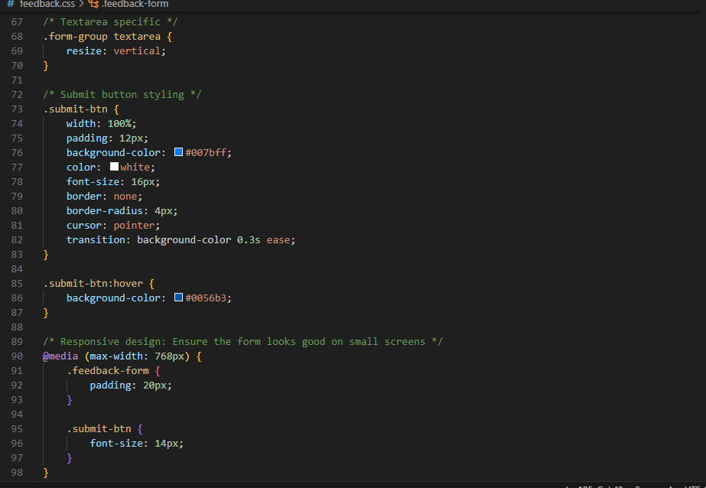

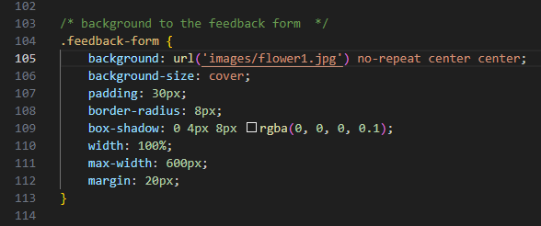

**HEADER:**

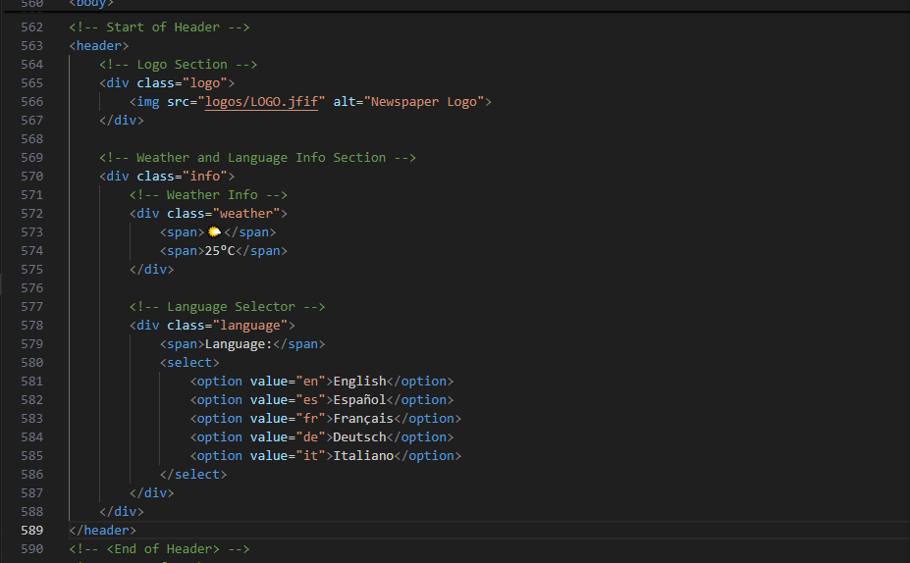

**World News Section (HTML):**

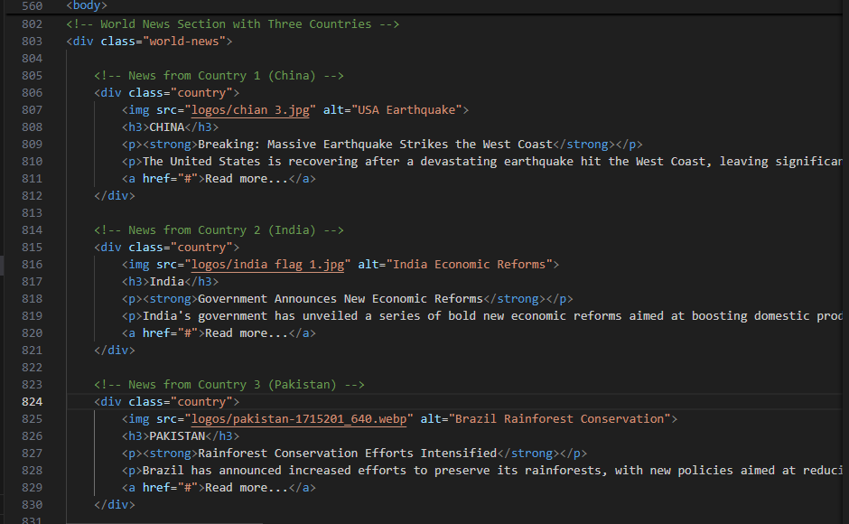

**HEADLINES SECTION (HTML):**

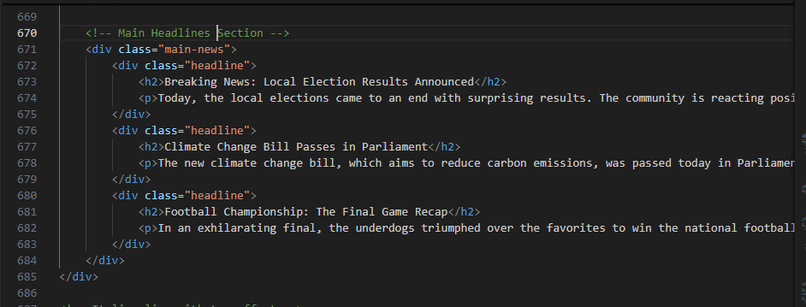

**SIDEBAR SECTION (HTML):**



**NAVBAR:** It allows smooth navigation between pages on the website.



**HOME:** It is the primary homepage of the website.

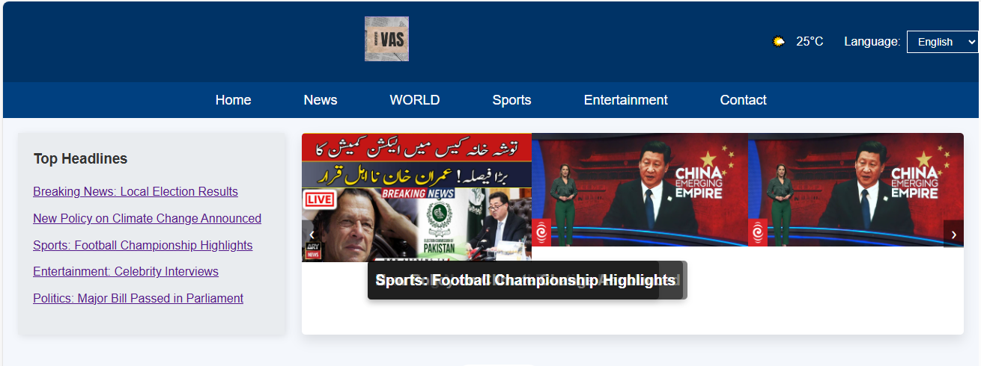

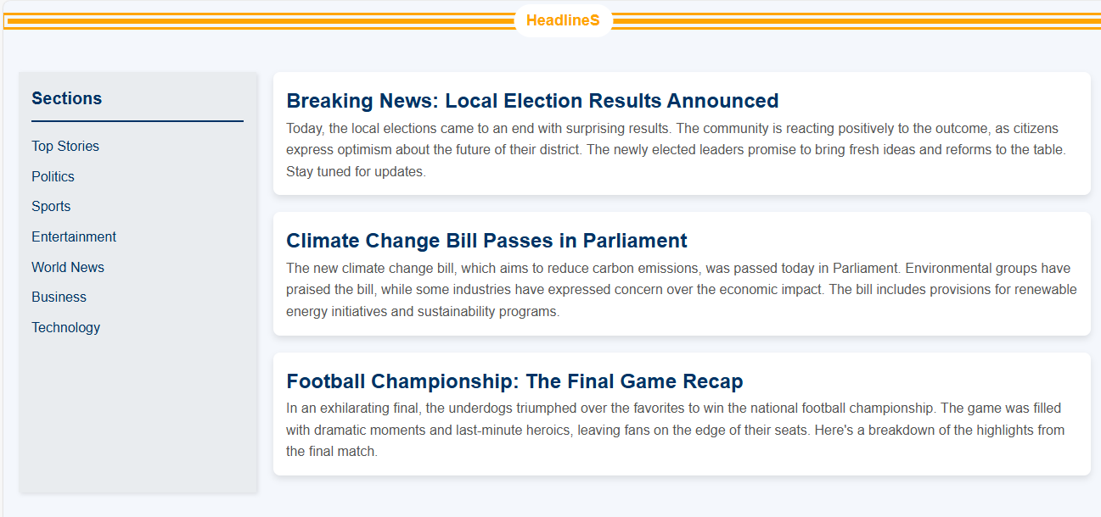

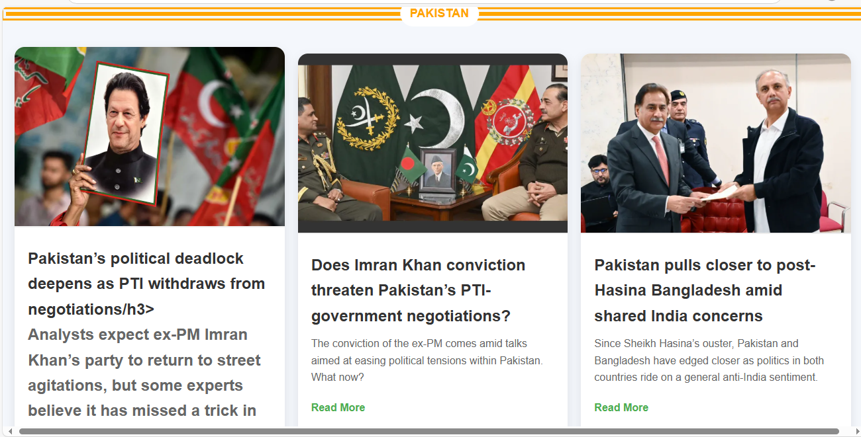

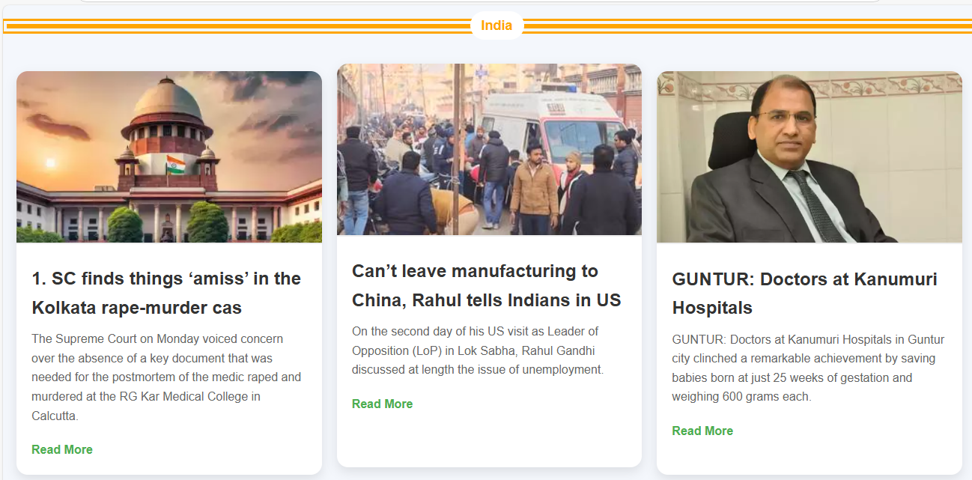



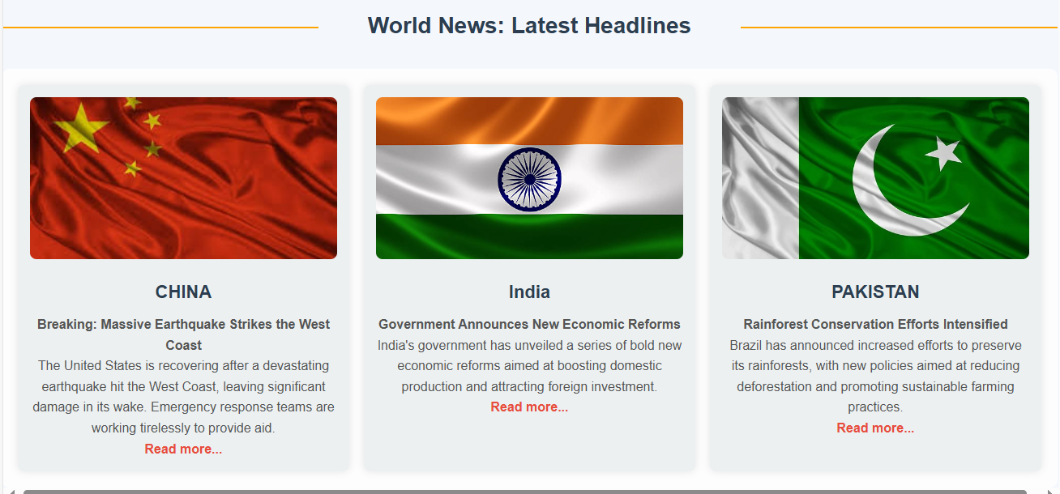

**CONTACT US:** It is used when the user requires assistance.

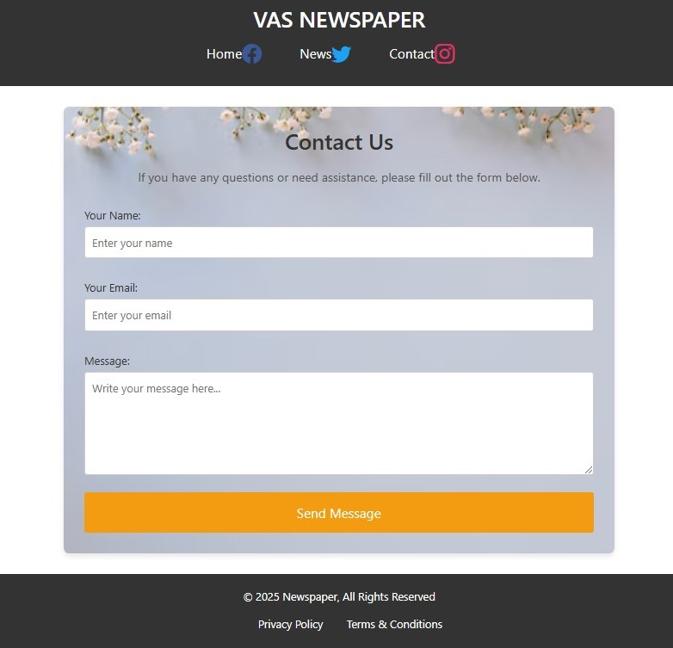

**FEEDBACK:** The feedback page allows users to share their opinions and suggestions.

